**Project Planning Phase**

**Project Planning Template (Product Backlog, Sprint Planning, Stories, Story points)**

|  |  |
| --- | --- |
| Date | 18 October 2022 |
| Team ID | PNT2022TMID27240 |
| Project Name | Project - AI - based localization and classification of skin disease with erythema. |
| Maximum Marks | 8 Marks |

**Product Backlog, Sprint Schedule, and Estimation (4 Marks)**

Use the below template to create product backlog and sprint schedule

|  |  |  |  |  |  |  |
| --- | --- | --- | --- | --- | --- | --- |
| **Sprint** | **Functional**  **Requirement (Epic)** | **User Story**  **Number** | **User Story / Task** | **Story Points** | **Priority** | **Team Members** |
| Sprint-1 | Registration | USN-1 | As a user, I can register for the application by entering my email, password, and confirming my password. | 3 | High | G.Charan Teja |
| Sprint-1 |  | USN-2 | As a user, I will receive confirmation email once I have registered for the application. | 2 | Medium | Dharani Vishal. |
| Sprint-2 |  | USN-3 | As a user, I can register for the application through Mobile number. | 3 | High | Jerlin T D.  Kishore R. |
| Sprint-2 |  | USN-4 | As a user, I will receive a conformation SMS. | 3 | High | G. Charan Teja. |
| Sprint-2 | Login | USN-5 | As a user, I can log into the application by entering login credentials. | 1 | High | Jerlin T D.  Dharani Vishal. |
| Sprint-3 | Dashboard | USN-6 | As a user, I can upload my images and get my details of skin diseases. | 3 | High | G. Charan Teja.  KIshore R. |

|  |  |  |  |  |  |  |
| --- | --- | --- | --- | --- | --- | --- |
| **Sprint** | **Functional**  **Requirement (Epic)** | **User Story**  **Number** | **User Story / Task** | **Story Points** | **Priority** | **Team Members** |
| Sprint-1 | Logout | USN-7 | As a user, I can logout successfully. | 2 | Medium | G.Charan Teja.  Dharani Vishal. |
| Sprint-4 | Feedback | USN-8 | As a customer care executive, I can be able to interact with all the customer and get their feedback which is used to enhance the scope of the project. | 2 | Medium | G. Charan Teja.  Jerlin T D. |
| Sprint-3 | Image processing, Localization. | USN-9 | The uploaded image is preprocessed and fed into the trained YOLO model. | 3 | High | G. Charan Teja.  Dharani Vishal.  Kishore R. |
| Sprint-4 | Classification and prediction. | USN-10 | The YOLO model classify and predict the type of disease and the area affected. | 3 | High | G. Charan Teja.  Dharani Vishal.  Jerlin T d.  Kishore R. |

**Project Tracker, Velocity & Burndown Chart: (4 Marks)**

|  |  |  |  |  |  |  |
| --- | --- | --- | --- | --- | --- | --- |
| **Sprint** | **Total Story Points** | **Duration** | **Sprint Start Date** | **Sprint End Date (Planned)** | **Story Points**  **Completed (as on**  **Planned End Date)** | **Sprint Release Date (Actual)** |
| Sprint-1 | 20 | 6 Days | 24 Oct 2022 | 29 Oct 2022 | 20 | 29 Oct 2022 |
| Sprint-2 | 20 | 6 Days | 31 Oct 2022 | 05 Nov 2022 | 20 | 05 Nov 2022 |
| Sprint-3 | 20 | 6 Days | 07 Nov 2022 | 12 Nov 2022 | 20 | 12 Nov 2022 |
| Sprint-4 | 20 | 6 Days | 14 Nov 2022 | 19 Nov 2022 | 20 | 19 Nov 2022 |

**Velocity:**

Imagine we have a 10-day sprint duration, and the velocity of the team is 20 (points per sprint). Let’s calculate the team’s average velocity (AV) per iteration unit (story points per day)

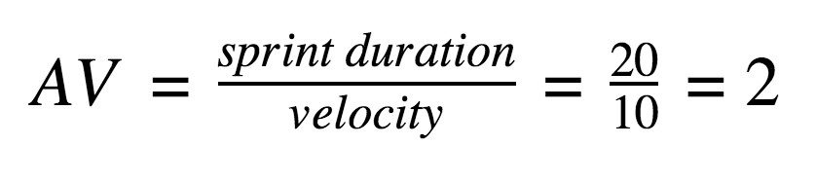

Average Velocity = Story Points per Day Sprint Duration = Number of (Duration) days per Sprint Velocity = Points per Sprint

# AV = 20 /6 =4

Therefore, the AVERAGE VELOCITY IS 4 POINTS PER SPRINT.

**Burndown Chart:**

A burn down chart is a graphical representation of work left to do versus time. It is often used in agile [software development](https://www.visual-paradigm.com/scrum/what-is-agile-software-development/) methodologies such as [Scrum](https://www.visual-paradigm.com/scrum/scrum-in-3-minutes/). However, burn down charts can be applied to any project containing measurable progress over time.

